***Driver Drowsiness Detection System using DLib***

**Anusmriti Shome, Pranav Garg, Aman Jain, Ritika Chopra, Vishal Choudhary, Dinesh Vij, Gurjot Singh Sodhi**

*Department of Computer Science Engineering*

*Apex Institute of Technology*

*Chandigarh University*

*Mohali, India*

*Email:* [*19BCS6081@cuchd.in*](mailto:19BCS6081@cuchd.in)*,* [*19BCS6067@cuchd.in*](mailto:19BCS6067@cuchd.in)*,* [*19BCS6074@cuchd.in*](mailto:19BCS6074@cuchd.in)*,* [*19BCS6071@cuchd.in*](mailto:19BCS6071@cuchd.in)[*19BCS6073@cuchd.in*](mailto:19BCS6073@cuchd.in)*,*

[*dinesh.e10419@cumail.in*](mailto:dinesh.e10419@cumail.in)*,* [*gurjot.e8010@cumail.in*](mailto:gurjot.e8010@cumail.in)

**Abstract—Fatigue and Drowsy state are the common reasons for road accidents. Every year road accidents due to driver’s sleepiness and fatigue increase. In this proposed paper, an application for the driver drowsiness detection system is introduced which will be helpful to prevent road mishaps that were mainly caused by driver’s fatigue, and hence it will help to improve traffic safety. This detection system deals with Deep learning algorithms as well as the DLib library to detect and predict the results. Also, an alert system is added to this application to alert the person if he/she is feeling drowsy. We have used a highly enhanced face tracking algorithm that can make the prediction more accurate. It uses 68 face landmarks to detect facial features. Detecting the facial feature using 68 landmarks is more accurate and precise than the PERCLOS and Haar cascading algorithm.**

**Keywords—Fatigue, Drowsiness, android-based system, PERCLOS**

# I. INTRODUCTION

Sleep is one of the basic human needs. Lack of sleep can cause the body to react unproductively and dysfunctionally and it can reduce both the response time and waking up.; also it can produce low alertness and loss of concentration. Due to which a person does not have the awareness to perform activities for example concentrating on a task, studying, or driving a car. Everybody needs good quality sleep. One in six road accidents resulting in death or injury is fatigue-related. Needless to say, many people aren't getting enough sleep, and it’s putting lives at risk.

According to research, 20% of people have revealed that they fall asleep at the wheel and 40% have admitted that this incident had happened at least once in their daily routine. Investigation shows that 40% of highway mishaps or accidents in India s are due to diver’s drowsiness. In view of these figures, we can easily conclude how drowsiness and fatigue can impact a person’s life; therefore we developed a driver safety system that also follows all the traffic rules and regulations. Here, we have also estimated the diver condition, in order to develop a detection system.

**II. RELATED RESEARCH**

In this existing research paper: "A Smartphone-based driver safety monitoring system using data fusion Sensors", Lee and Chung [3], used a Data fusion method to detect the drowsiness of the driver. In this process, various environmental variables such as variation of biological signals, the temperature inside the vehicle, eye properties, and vehicle speed are used to estimate the threshold value. Their system is designed specifically for Android-based systems, where no additional costs or tools are required to measure security-related data. The system has 96% efficiency to predict whether the driver is alert and awake, and 97% efficiency to predict if he is feeling drowsy. This information can be used to find out if the driver is feeling drowsy. This paper mentions techniques like Face detection. Eye-tracking and Eye position detection are effective methods of detecting the driver's position [2]. This model uses head and facial movement to detect the driver's position and send an alert message within 0.5 seconds. The driver performance is analyzed in the form of graphs as well as transmissions.

 This existing research paper “Detection of fatigue using Smartphone'' aims to use a Smartphone (with Android operating system or IOS) to detect fatigue in the driver” [4] they use the frontal camera of the Smartphone for the extraction of images of the driver. After extraction, they use advanced computer algorithms to detect faces and eyes. In this letter, he mentioned that dizziness, tilting, and blinking of eyes can also be considered as symptoms of drowsiness. The smartphone is used to help the driver [5] with drowsy driving detection systems [6]. The PERCLOS (Percent of the time Eyelids are closed) metrics is a new technique to which is used to measure drowsiness.

The development and usability of HCI have increased. Now they have implemented adequate usability criteria and efficiently met the needs of the users. A pertinent aspect is that it is a simple interaction that helps people to meet their needs, overcome their limitations and assist with special skills to implement using low-cost systems. Advanced systems are based on computer vision. The system uses the Viola-Jones algorithm as well as the camshaft algorithm [6]. This paper is working on developing a software framework for the timely and accurate detection of the face and eyes that can be used to detect a person's drowsiness. Here, they input multiple facial features which will be the dependent variable of threshold values [3].

# III. LITERATURE REVIEW

The existing model of Drowsiness detection [11] has three approaches to detect drowsiness and fatigue. Those approaches are listed below:

1. Vehicle-Based Detection system
2. Behavioral-Based Detection System
3. Physiological-based Detection system

**VEHICLE-BASED DETECTION SYSTEM**

The ‘Vehicle-Based Detection System’ model measures the lane position, angle, and movement of steering, etc. These parameters are constantly measured and if it crosses a specific threshold value it alerts the driver.

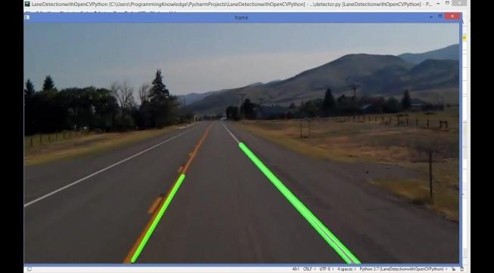

*Fig 1: Measuring Lane marking in Vehicle detection system*

**BEHAVIORAL-BASED AND PHYSIOLOGICAL BASED DETECTION SYSTEM**

Behavioral-based models and physiological-based models constantly measure the head posture, physiological signals ECG and EOG [11][15]. Drowsiness is detected through pulse rate, heartbeat, and brain information and if it crosses the threshold value it will alert the driver. In these existing models, external devices are required to collect information about physical movement. The driver needs to connect himself to that device so that it can easily read and collect the data.

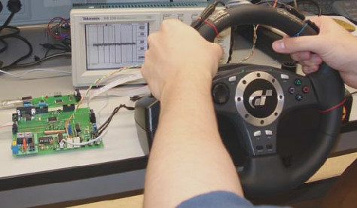

*Fig 2: Pulse rate, the heartbeat collection process*

*(Hands-on the wheel: a Dataset for Driver Hand Detection and Tracking)*

In this proposed system, we are using deep learning that will provide more accuracy. This detection system will detect facial features and will track the facial feature’s activity like yawning, eye closure, eye blinking, etc. Using this feature, the model will predict the result and if the predicted value crosses the given threshold value then the model will deliver a signal to the alert system that will alert the driver. The alert system will deliver a message to alert.

This system is a real-time analysis system. It utilizes image processing algorithms to detect eyes and faces. Space predictors are used to identify 68 facial landmarks. Algorithms are used to track objects for the eye to continuously track. This paper focuses on the modeling of a system that can easily detect fatigue and sleep disorders and send real-time warnings. The system will record the driver's eyes using an external camera. Driver fatigue symptoms can be easily detected using the developed algorithm. It sends a signal to the alert system when the predicted value exceeds a certain value of the fatigue threshold. The alert system will send alert messages to the family and close friends of the driver. This paper uses a faster algorithm than PERCLOS. Also using a space predictor is better than HAAR cascading.

[21] The paper presents mathematics based on a new concept for solving sleep detection problems in embedded systems. It presents an embedded system based on image processing techniques. It uses PERCLOS (percentage of eyelid closure over time) to estimate the distance between the eyelids and using the CAMSHIFT algorithm it tracks eye movement to make predictions. [22] In this referred paper, a model for the Advanced Driver Assistance System (ADAS) is introduced to reduce the number of accidents. It uses visual information and artificial intelligence. Facial detection is based on eye recognition and skin color information is based on symmetry. [23] This paper presents the development of a solution to detect a driver's drowsiness in real-time and issue alerts to avoid possible traffic accidents. In particular, an analysis of the methods used for the detection of drowsiness by computer vision is performed, focusing on the use of facial reference points. [24]

# IV. PROBLEM FORMULATION

## Every year the number of deaths and injuries in road accidents is increasing due to human error. Fatigue and driving are very dangerous and very difficult to diagnose. People are aware of the dangers of drowsiness and driving that but do not understand the dangers of drowsiness because there is no instrument to measure a driver's sleep. If the driver fails to focus on driving, it reduces the driver's reaction time and impairs steering behavior.

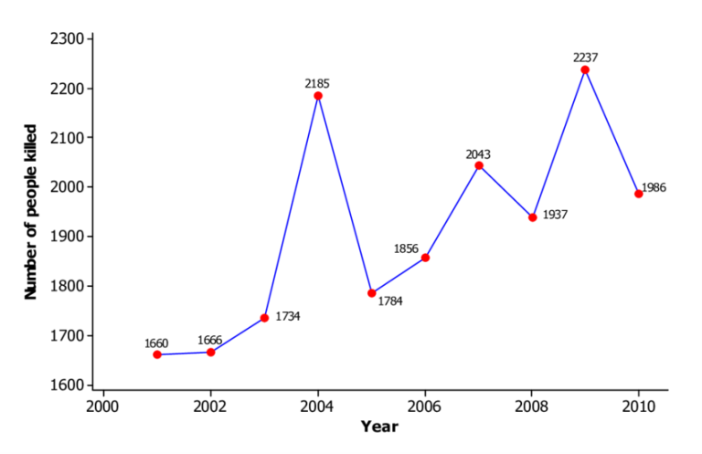

*Fig 3: Accident rate due to drowsiness*

## This model will be very effective in reducing road accidents. As with the help of this model, the driver will be easily altered. The sensor observes the movements of the face and the eye and some other body movements and concludes whether the driver is getting drowsy or not. It will also provide tips that the driver has to follow to remain awake; like parking his vehicle by the roadside and taking some rest or splashing some water and then moving the way to his destination. This intermediate neural network project aims to create drowsiness detection systems that will perceive when a person's eyelids are closed for a few seconds. This system will send a signal to the alarm system to alert the driver when the drowsiness is detected.

# V.  OBJECTIVE

The main objectives of this proposed model are mentioned below:

* To recommend a process to detect drowsiness while driving and to detect the physiological changes during drowsiness.
* Build an intelligence system that can be used to monitor fatigue and drowsiness by closing your eyes and yawning.
* To analyze the data obtained by the detective device and to develop an algorithm for yawning detection to monitor driver fatigue level.
* To create an alarm system that will use the prediction of the deep learning algorithm to notify the driver if the driver fatigue level predicted by the model is higher than a certain level.

# VI.  METHODOLOGIES

This proposed paper uses the enhanced library that is written in the python programming language. OpenCV, as well as DLib libraries, are mainly used to formulate the solution for Image acquisition. Deep learning algorithms are used to detect the facial features that will be responsible for calculating the output value. At last, an alert is connected to the software to notify the driver if he/she is feeling drowsy. The application needs to follow certain steps to predict the desired outcome.

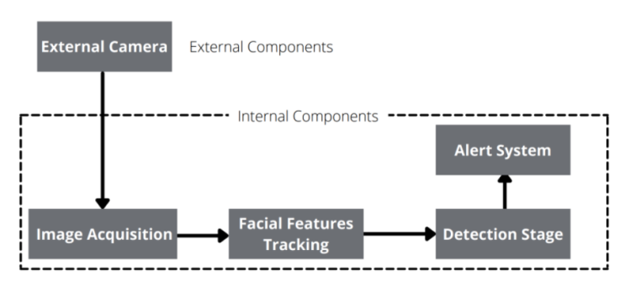

*Fig 4: Model flowchart*

**IMAGE ACQUISITION**

The model will be using the OpenCV framework for image acquisition. It is used to intake the live video that will be captured using an external camera which is embedded with the following algorithm.

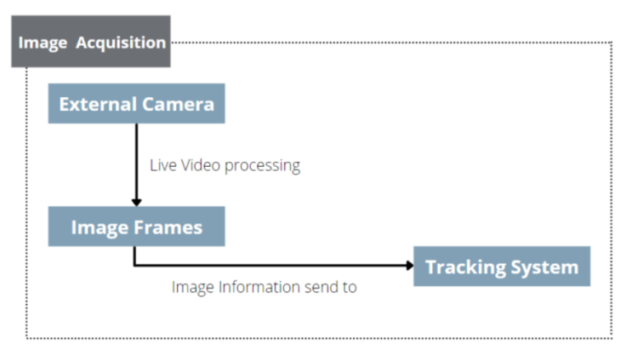

*Fig 5: Image Acquisition flowchart*

**FACIAL FEATURES TRACKING**

After that, the acquired image frames are fed into different modules such as the Facial tracking systems and detection systems. These systems have integrated the DLib module which has pre-implemented ML algorithms.

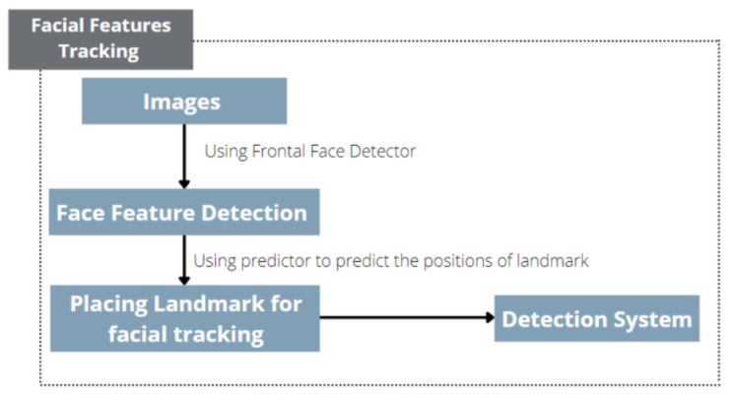

*Fig 6: Facial Tracking flowchart*

These libraries build a Face_recognition model for our application. The Face_recognition model uses a deep learning algorithm. This deep learning algorithm has 99.38% accuracy. The Face_recognition model has built-in functions that perform all the facial detection parts such as face recognition, detection, and identification tasks. It uses the shape predictor 68 landmark dataset to detect the facial features.

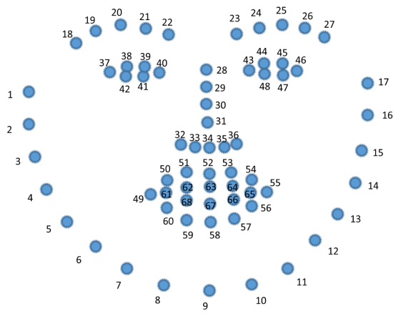

*Fig 6(a): 68 Facial Landmark Datapoint*

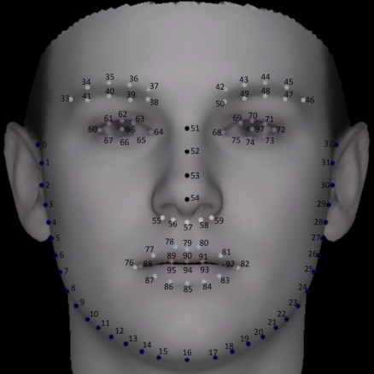

*Fig 6(b): 68 Facial Landmark Datapoint*

*(WFLW dataset 2019)*

Face_landmarks function of the deep learning algorithm will return a dataset of all tracked features in the image. Each feature of the dataset will further have a ‘name’ and ‘list of points’ for all facial features of the face. It will use the OpenCV library to track the facial features and inbuilt DLib function to detect the face and then apply algorithms to accurately predict all 68 Landmark points in the face. Using the Landmark points we will take the data of the eye which has 6 Landmark points and will be calculating the ratio which is going to decide Driver Drowsiness status. The ratio will be calculated using the shortest distance between the eyelids, that is the upper and lower Landmark points in the eye and calculating distance will be using the Euclidean Distance formula.

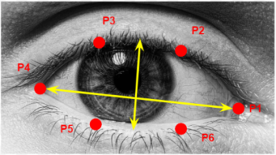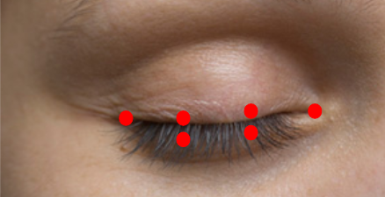

*Fig 7: Calculating Euclidean distance between upper and lower landmark points in the eye*

**DETECTION SYSTEM**

After a lot of research by Scientists, they have concluded that the ratio between 0.21 and 0.25 is considered to be in the Drowsed state. Using this ratio we will set a threshold value and if the driver’s drowsiness crosses this value, the alert system will forward an alert message to the driver.

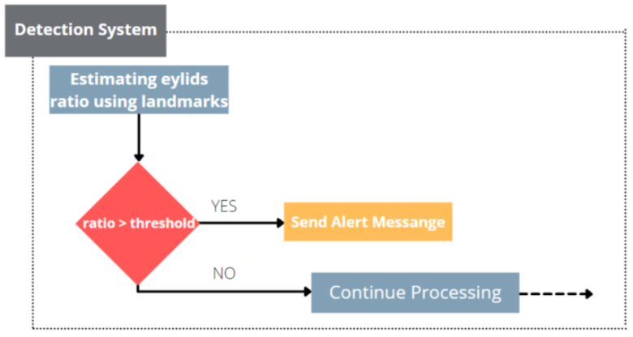

*Fig 8: Detection system flowchart*

In the alert system, it will use the SMTP module which will forward alert email messages to the driver’s family and close friends. The model can be extended where we can generate emergency calls.

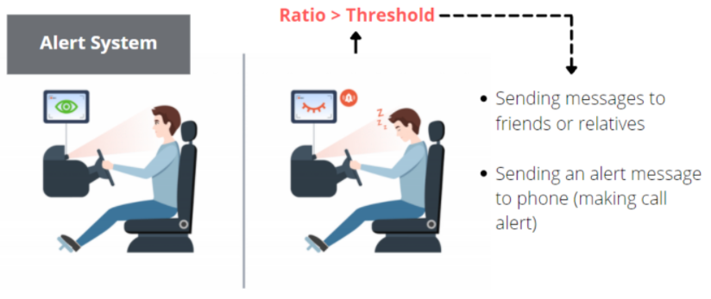

*Fig 9: Alert System*

# VII. RESULTS

The whole program can be embedded in an external camera system that will record all the live data of the facial feature and based on the recorded data the result of the system will be determined. The face tracking system sets all facial features, and the detection system combines all calculated values ​​with thresholds. If the predicted value of the detection system is greater than the threshold value, it will send a message to the alert system.

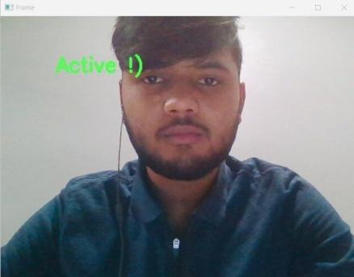

*Fig 10(a): Active state of Detection System*

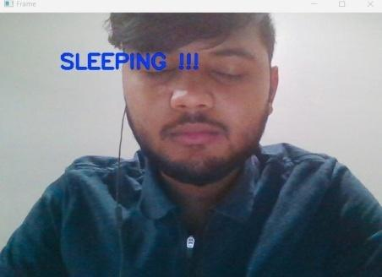

*Fig 10(b): Drowsy state of the Detection system*

The alert system after receiving the message will send an alert message through emails.

**CONCLUSION**

We have shown that the dashboard camera embedded with the drowsiness detection algorithm can be used effectively for traffic safety. We have designed a driver drowsiness detection system that uses deep learning algorithms as well as facial feature predictors for drowsiness detection. We have used space predictor 68 landmarks to track the facial feature and DIL library to calculate the threshold values for drowsiness. We found that space predictor 68 landmarks is more useful than the PERLOC algorithm. The space 68 landmarks are used to produce more accurate answers. The model uses a deep learning algorithm with an accuracy of 99.38%. It has built-in functions to perform face detection, recognition, and identification tasks. We have shown how the proposed model is better than the existing model. If the calculated value is more than the threshold the alert system will send an alert message to the driver as well as his/her family member. In our future work, we will try to strengthen the alert system

**REFERENCES**

[1] Lee, Kyong & Kim, Whui & Choi, Hyun & Jang, Byung. (2019). A Study on Feature Extraction Methods Used to Estimate a Driver’s Level of Drowsiness.   
710-713. 10.23919/ICACT.2019.8701928.

[2] Hong, Tianyi & Qin, Huabiao. (2008). Drivers drowsiness detection in embedded system. 1 - 5. 10.1109/ICVES.2007.4456381.

[3] Lorraine Saju, Christeena J, Farhana Yasmin, Surekha Mariam, “Drowsiness detection system for drivers using HAART training and template matching”, IJEAST, Vol. 1, Issue 6, April 2016.

[4] Dwipjoy Sarkar, Atanu C, “Real-Time Embedded System Application for Driver Drowsiness and Alcoholic Intoxication Detection”, IJETT, Volume 10 Number 9, April 2014.

[5] SrinivasuBatchu, S Praveen Kumar, “Driver Drowsiness Detection to Reduce the Major Road Accidents in Automotive Vehicles”, IRJET, Volume 02 Issue 01, April 2015.

[6] Al-Sultan, Saif & Al-Bayatti, Ali & Zedan, Hussein. (2013). Context-Aware Driver Behavior Detection System in Intelligent Transportation Systems. IEEE Transactions on Vehicular Technology. 62. 4264 - 4275. 10.1109/TVT.2013.2263400.

[7] Ahmed, Faysal & Rayhan, Md & Rahman, Shahriar & Benazir, Neephat & Chowdhury, AZM & Imran, Md. (2019). Controlling Multimedia Player With Eye Gaze Using Webcam. 10.1109/ICREST.2019.8644103.

[8] Adithya Sajikumar, Anandu Prasad, Aravind Aji, Arun K Stanly, Jibin Baby, Neethu Maria John, 2021, Save The Drowsy Driver Detection, INTERNATIONAL JOURNAL OF ENGINEERING RESEARCH & TECHNOLOGY (IJERT) ICCIDT – 2021 (Volume 09 – Issue 07),

[9] SaeidFazli, Parisa Esfahani, “Tracking Eye State for Fatigue Detection”, ICACEE, November 2012. Gao Zhenhai, Le DinhDat, Hu Hongyu, Yu Ziwen, Wu Xinyu, “Driver Drowsiness Detection Based on Time Series Analysis of Steering Wheel Angular Velocity”, IEEE, January 2017.

[10] Pratama, Bagus & Ardiyanto, Igi & Adji, Teguh. (2017). A review on driver drowsiness based on image, bio-signal, and driver behavior. 70-75. 10.1109/ICSTC.2017.8011855.

[11] Sahayadhas A, Sundaraj K, Murugappan M. Detecting driver drowsiness based on sensors: a review [published correction appears in Sensors (Basel). 2021 Jan 11; 21(2):]. Sensors (Basel). 2012; 12(12):16937-16953. Published 2012 Dec 7. Doi: 10.3390/s121216937

[12] B. Alshaqaqi, A. S. Baquhaizel, M. E. Amine Ouis, M. Boumehed, A. Ouamri, and M. Keche, "Driver drowsiness detection system," 2013 8th International Workshop on Systems, Signal Processing and their Applications (WoSSPA), 2013, pp. 151-155, DOI: 10.1109/WoSSPA.2013.6602353.

[13] M. A. Assari and M. Rahmati, "Driver drowsiness detection using face expression recognition," 2011 IEEE International Conference on Signal and Image Processing Applications (ICSIPA), 2011, pp. 337-341, DOI: 10.1109/ICSIPA.2011.6144162.

[14] V, Kiranmayee. (2021). Driver Drowsiness Detection System. International Journal for Research in Applied Science and Engineering Technology. 9. 1226-1231. 10.22214/ijraset.2021.36124.

[15] R. N. Khushaba, S. Kodagoda, S. Lal and G. Dissanayake, "Driver Drowsiness Classification Using Fuzzy Wavelet-Packet-Based Feature-Extraction Algorithm," in IEEE Transactions on Biomedical Engineering, vol. 58, no. 1, pp. 121-131, Jan. 2011, DOI: 10.1109/TBME.2010.2077291.

[16] Sistla, V., Kolli, V.K.K., Kukkapalli, N.B., Katuri, S.S., Vallabhajosyula, S. (2020). Stacked ensemble classification-based real-time driver drowsiness detection. International Journal of Safety and Security Engineering, Vol. 10, No. 3, pp. 365-371. <https://doi.org/10.18280/ijsse.100308>

[17] Garcia, I. & Bronte, Sebastian & Bergasa, Luis & Almazán, Javier & Yebes, José. (2012). Vision-based drowsiness detector for real driving conditions. IEEE Intelligent Vehicles Symposium, Proceedings. 618-623. 10.1109/IVS.2012.6232222.

[18] Mashru, Dishita & Gandhi, Vaibhav. (2018). Detection of a Drowsy state of the Driver on-road using wearable sensors: A survey. 691-695. 10.1109/ICICCT.2018.8473245.

[19] Dwivedi, Kartik & Biswaranjan, Kumar & Sethi, Amit. (2014). Drowsy driver detection using representation learning. Souvenir of the 2014 IEEE International Advance Computing Conference, IACC 2014. 995-999. 10.1109/IAdCC.2014.6779459.

[20] Alshaqaqi, B., Baquhaizel, A. S., Amine Ouis, M. E., Boumehed, M., Ouamri, A., & Keche, M. (2013). Driver drowsiness detection system. 2013 8th International Workshop on Systems, Signal Processing and Their Applications (WoSSPA).

[21] Hong, Tianyi & Qin, Huabiao. (2008). Drivers drowsiness detection in embedded system. 1 - 5. 10.1109/ICVES.2007.4456381.

[22] B. Al Shaqaqi, A. S. Baquhaizel, M. El Amine Ouis, M. Boumehed, A. Ouamri, and M. Keche, "Vision-based system for driver drowsiness detection," 2013 11th International Symposium on Programming and Systems. 8th International Workshop on Systems, Signal Processing and Their Applications (WoSSPA).

[23] L. D. S. Cueva and J. Cordero, "Advanced Driver Assistance System for the drowsiness detection using facial landmarks," 2020 15th Iberian Conference on Information Systems and Technologies (CISTI), 2020

[24] J. W. Baek, B. Han, K. Kim, Y. Chung, and S. Lee, "Real-Time Drowsiness Detection Algorithm for Driver State Monitoring Systems," 2018 Tenth International Conference on Ubiquitous and Future Networks (ICUFN), 2018

[25] M. Omidyeganeh, A. Javadtalab, and S. Shirmohammadi, "Intelligent driver drowsiness detection through the fusion of yawning and eye closure," 2011 IEEE International Conference on Virtual Environments, Human-Computer Interfaces and Measurement Systems Proceedings, 2011

[26] Y. Katyal, S. Alur, and S. Dwivedi, "Safe driving by detecting lane discipline and driver drowsiness," 2014 IEEE International Conference on Advanced Communications, Control and Computing Technologies, 2014,